1) logo Top left as per attachment Logo of BEQUICKELEKTRIEN

2) Header Phone nr still not changed

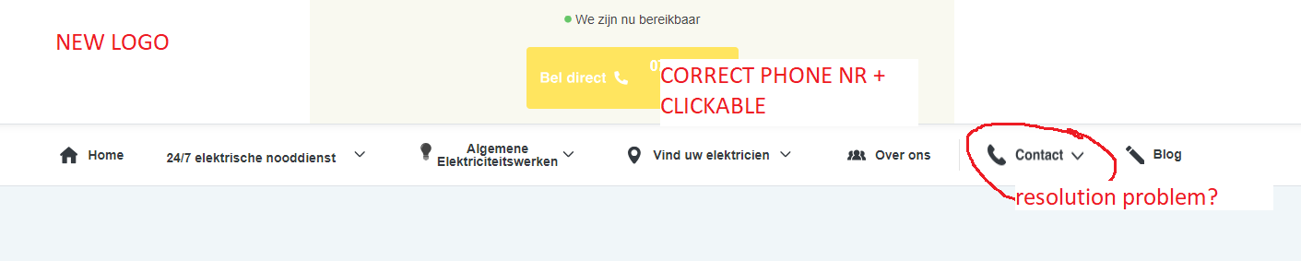

3) none of the phone nrs are clickable please check all pages and make sure right phone nr and clickable, they should open possible phone call once pressed +32 456 81 76 56

4) no symbols next to the menus and subpages header

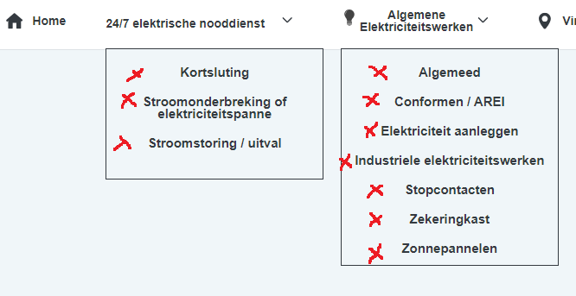

5) in menu Algemene Elektriciteitswerken / subpage Algemeed should be Algemeen

6) in menu Vind uw elektricien, there should be a link **bekijk alle locaties** 🡪 this page should be like <https://stroomprobleemkwijt.be/elektricien> but with modified area codes and cities as per document provided name of document

7) in the same menu there is a box where is written vul hier je plaats in, when visitor types there area code, city what is available on **bekijk alle locaties** page then it should autocomplete and once clicked the landing page should be (check point 9, its general landing page for confirming we have found an electrician for that area:

We hebben een technieker voor u beschikbaar in u gekozen regio : the selected area or typed area code/city

Bel ons nu voor een afspraak [+32 456 81 76 56](tel:%20+32456817656)

Simple page to make the call/ with clickable phone nr / and the selected area code or city name by the user

Please check this to clarify

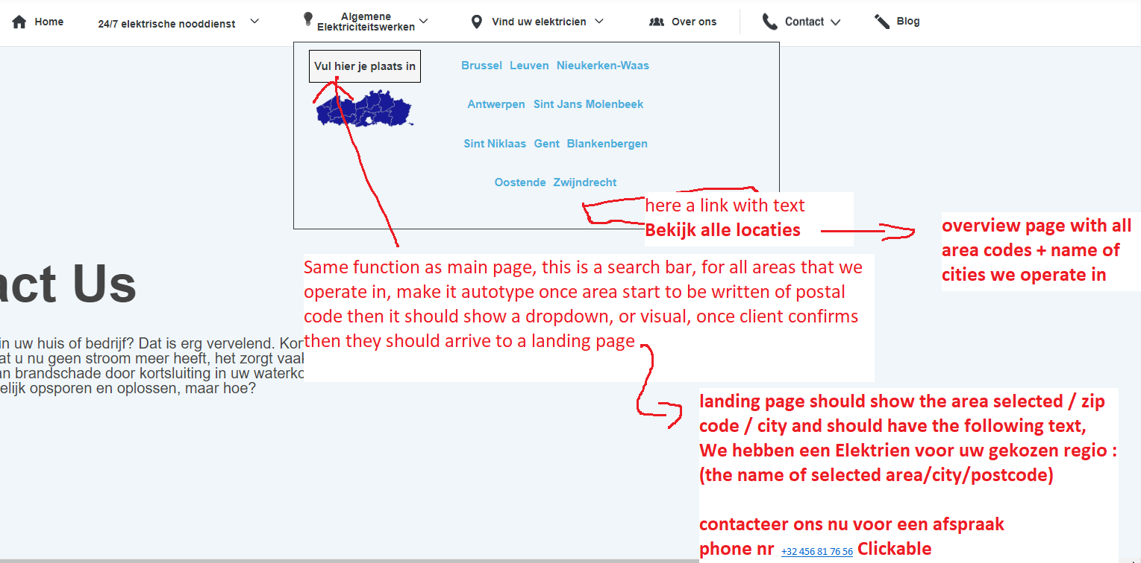

8) on the main page,

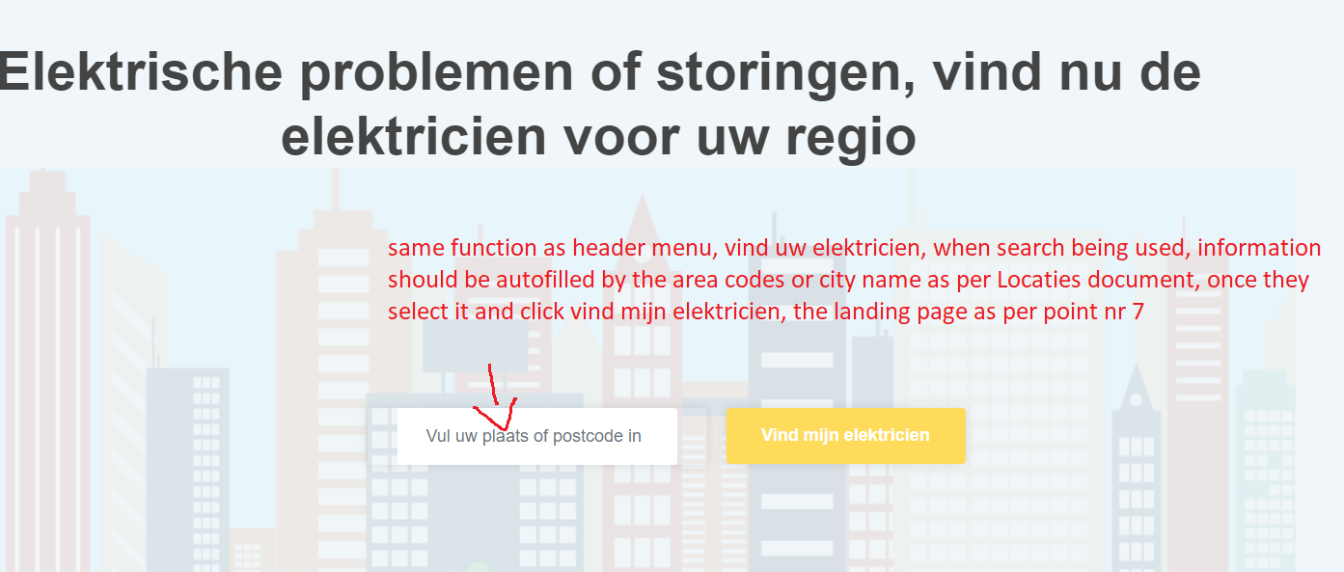

9) Landing page after confirmed location / area code

Simple page, same background as usual with following text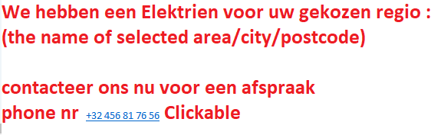

10 ) on page OVER ONS

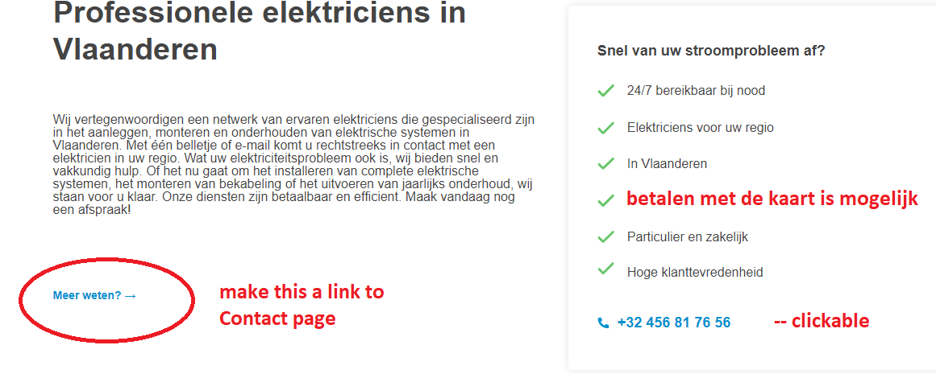

11) remove blog overview

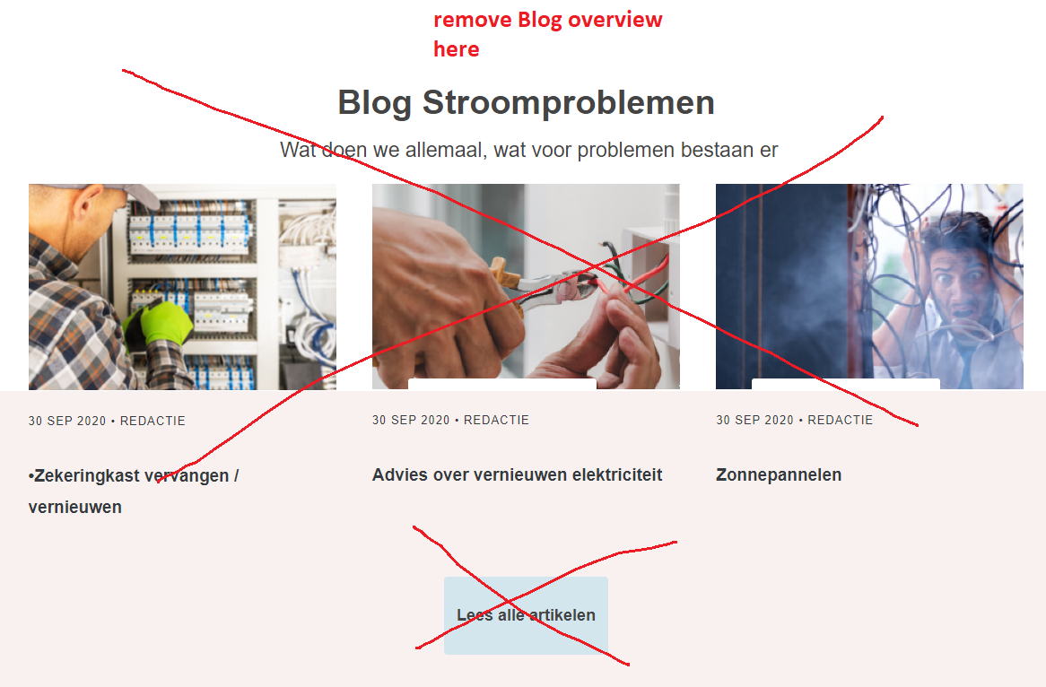

12 )

Same page lower, BEKIJK ALLE LOCATIES, should be a link to page with all location/cities area codes as per example point nr 6 but with my provided cities and area codes.

13 ) remove this totally

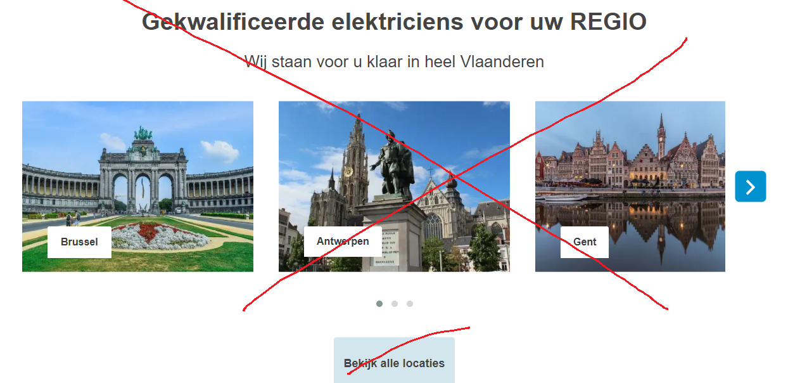

14 ) this search bar should work, as per main menu search and body search/ this is to search what area, so same functions as point 8

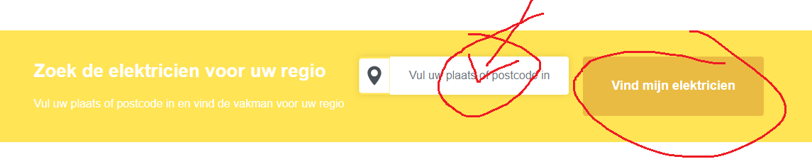

15 )check, if now clear feel free to ask

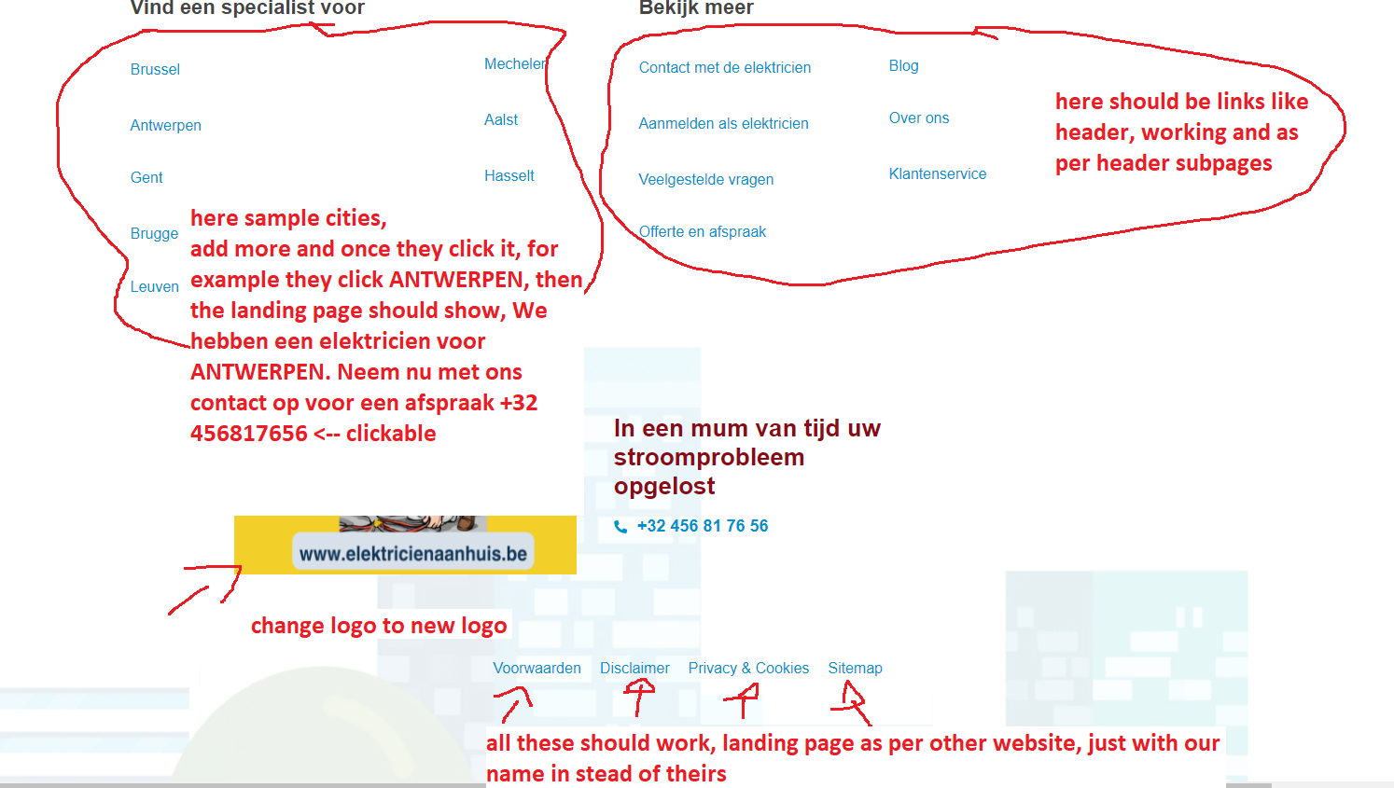

16) i think this one is clear

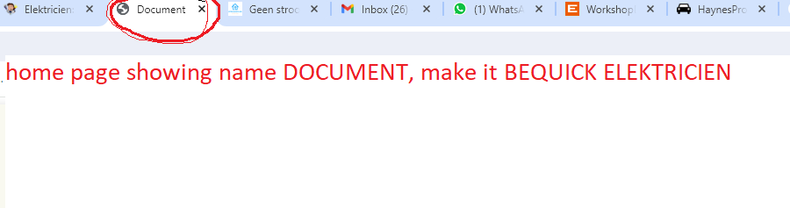

17 ) remove the BLOG from title and replace it with LIFTEN

Landing page of LIFTEN

Use picture LIFTEN, and add the following text on the page :

Wij hebben ook aan techniekers die werken uitvoeren aan alle merken van liften, wij doen onderhoud en herstelling voor zowel particulier als bedrijven.

Meer info ? contacteer ons op [+32 456 81 76 56](tel:%20+32456817656) 🡨 **clickable link**

Make nice but simple.